- Unzip files “Delta Block Box v2.0.24”.

- Click to enter the folder “Delta Block Box v2.0.24”, and open the main program “DeltaBlackBox”.

- To use the one-click download feature, click “Download Logs” in the top right corner, and a new window will open.
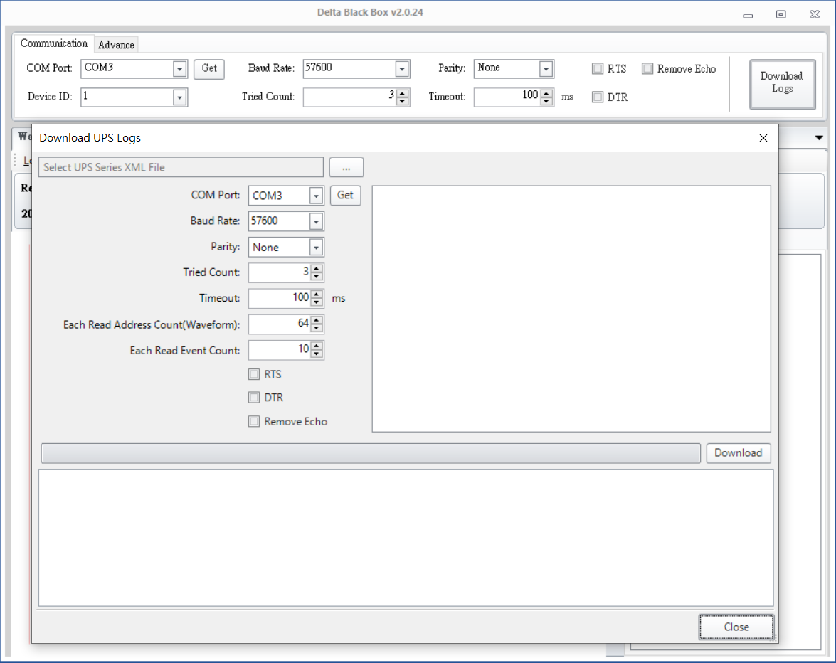
2
1

- Click the button at the top of the window and select “DPM GEN2_update”.
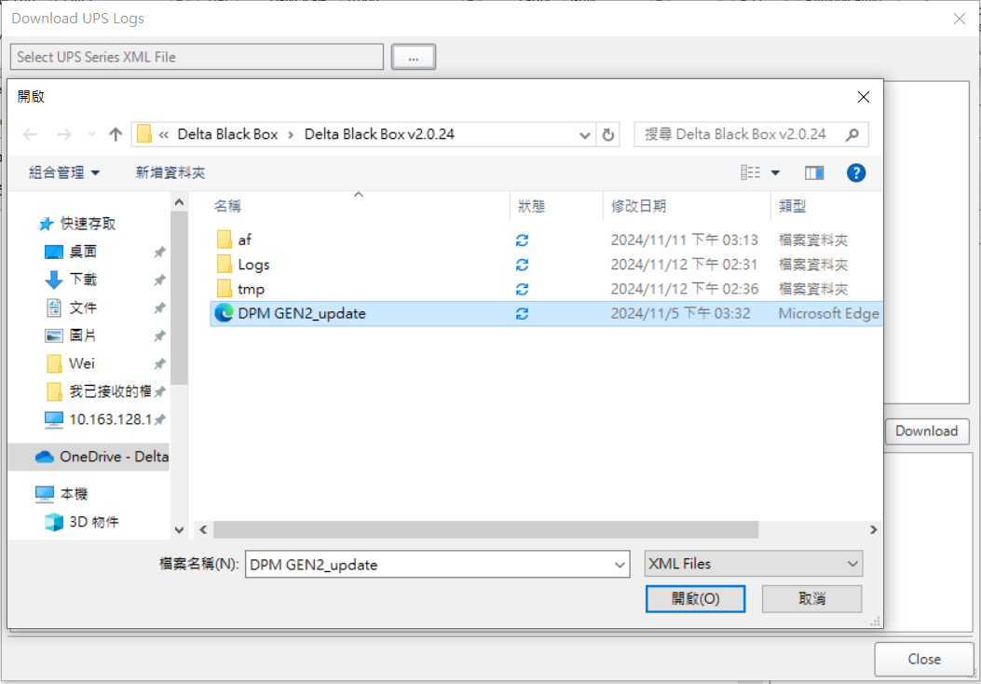
2
3
1

5-1. Select the COM port.
5-2. Check “Remove Echo”.
5-3. Select the module to download.
5-4. Click “Download”.
5-5. The window below will display “Start Downloading”.
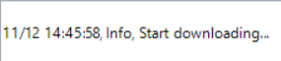
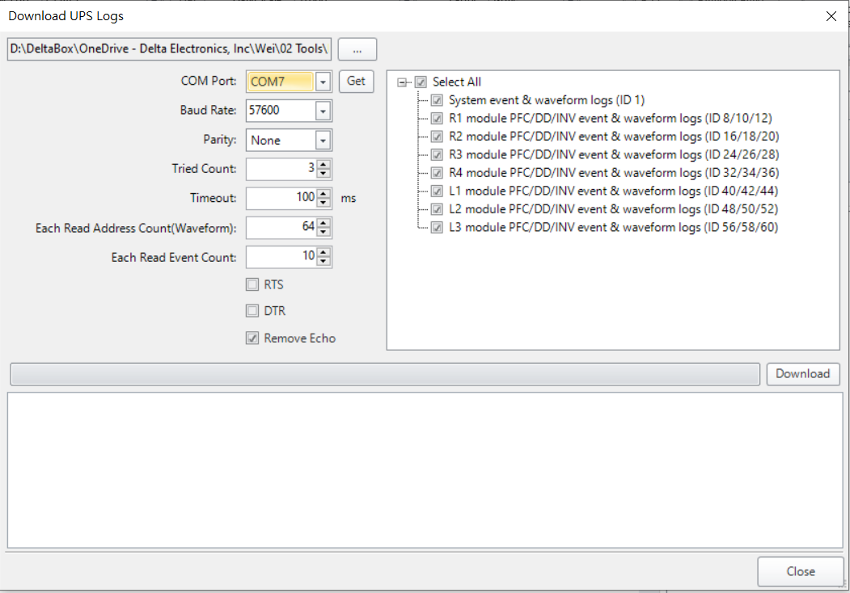
5
4
3
2
1

- Wait for the completion window.
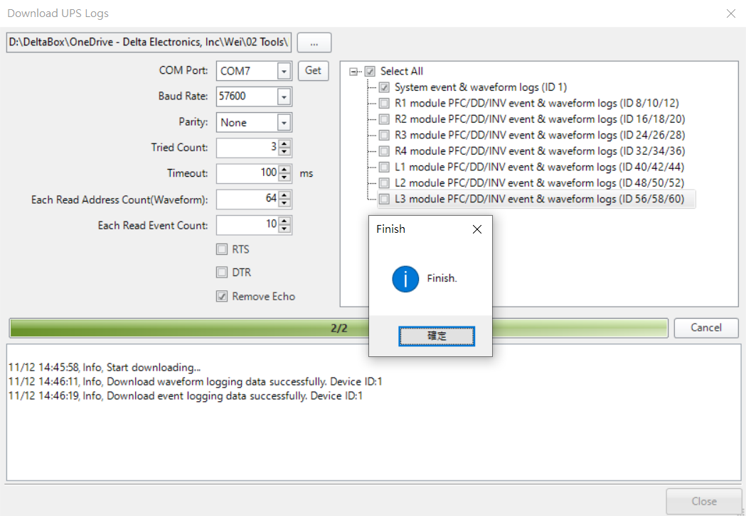
- After the download is complete, the downloaded compressed file will appear in the folder.

NOTE: To download again, simply reselect the module you want to download and click “Download”.